**Step 1: Login to production data stage server b01aciisd004 as root:**

**Step 2: Remove GSK of version 8.0.50.84:**

# verify which versions of GSK have been installed

lslpp -l | grep gsk

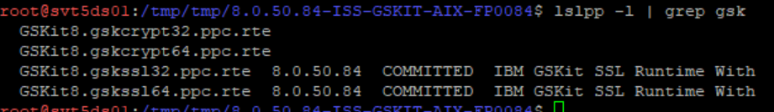

# simply press key “Enter” to go to next page when running **smitty**

Smitty

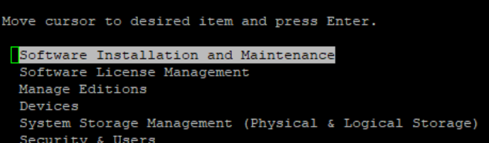

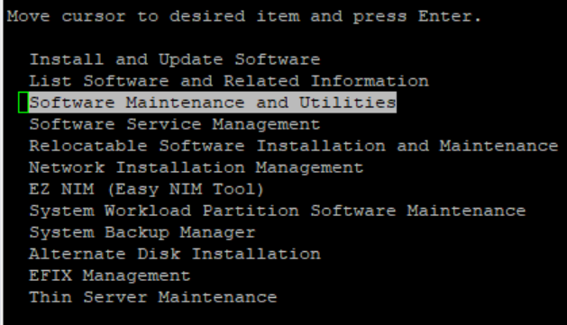

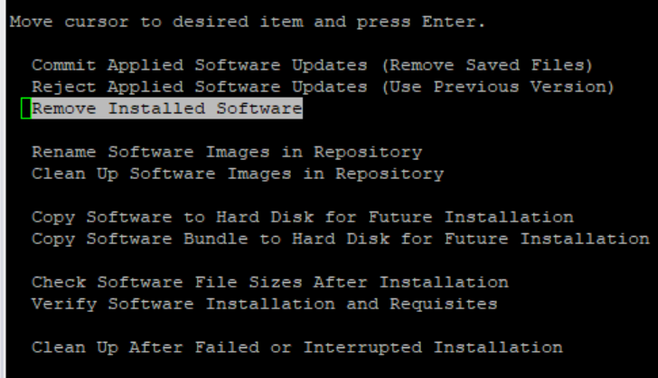

# enter “GSKit8.gskssl64.ppc.rte” into “SOFTWARE name”

# scroll the page down to “PREVIEW only” and press key “Tab” to change value to “no”

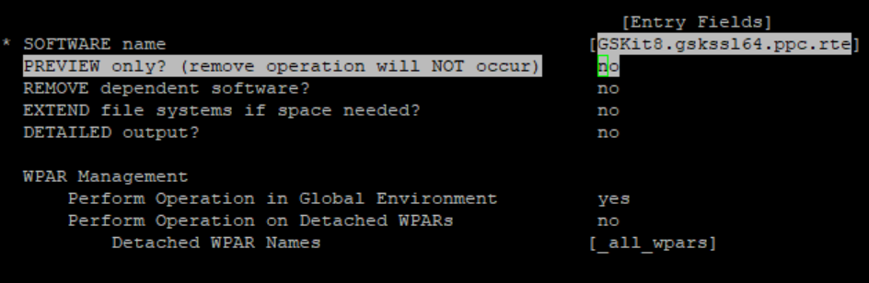

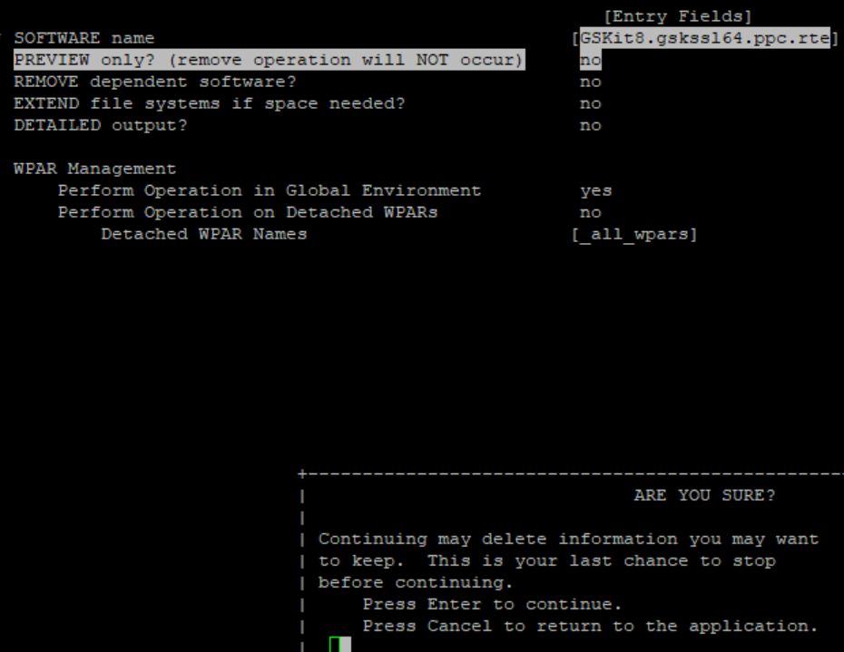

# press key “Enter”

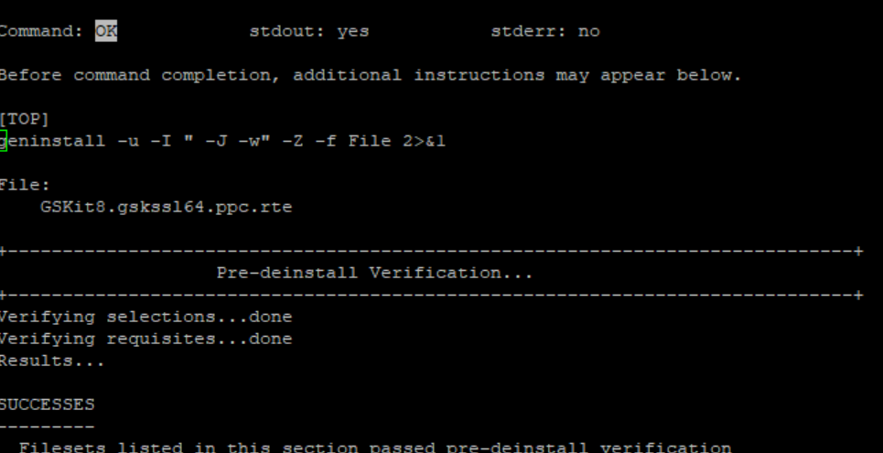

# enter combined keys: “Esc + 0” to exit smitty

# repeat the processes above to remove “**GSKit8.gskssl32.ppc.rte**” if it has been installed

lslpp -l | grep gsk

# ignore the gskcrypt below

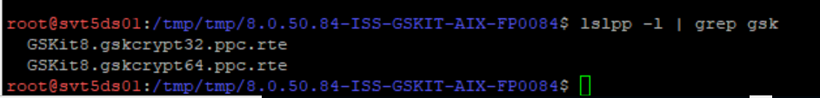

**Step 3: Download** *sds631_aix_ppc64_gskit.tar* **and put it to the folder /tmp:**

cd /tmp

wget http://bejgsa.ibm.com/gsa/bejgsa/home/d/l/dlyt/web/public/gskit/sds631_aix_ppc64_gskit.tar

**Step 4: Install GSK of version 8.0.14.26:**

tar xvf sds631_aix_ppc64_gskit.tar

cd sdsV6.3.1

cd ibm_gskit

# several files with the suffix rte can be seen

ls

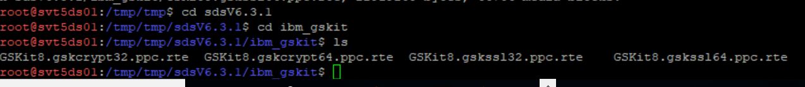

# simply press key “Enter” to go to next page when running **smitty**

smitty



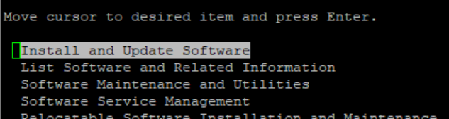

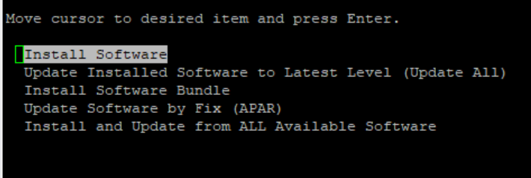

# enter location of GSK: ./

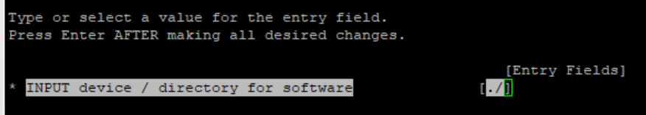

# scroll the page down to “ACCEPT new license agreements” and press key “Tab” to change value to “yes”

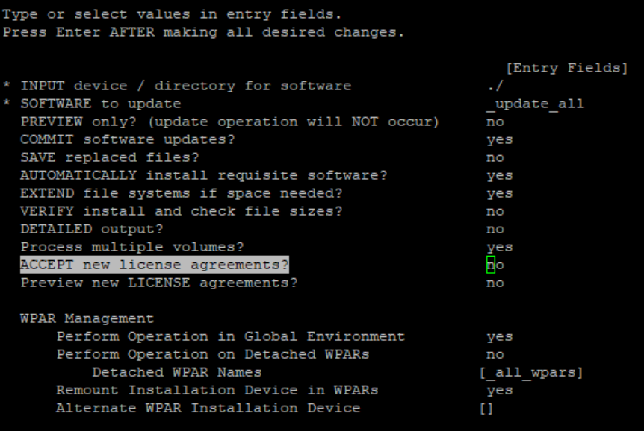

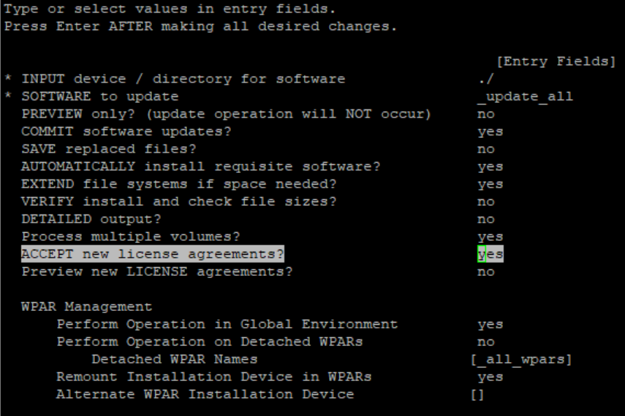

# press key “Enter”

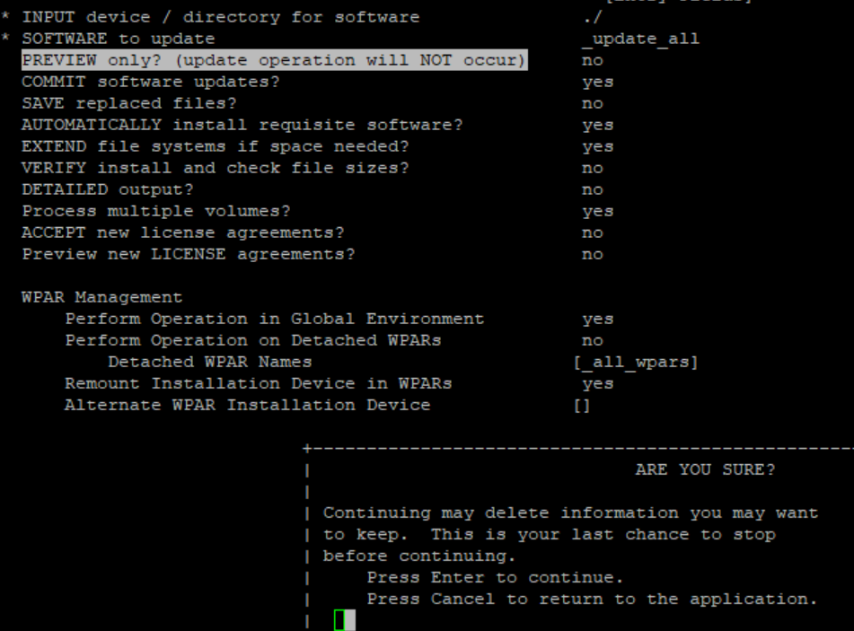

# press key “Enter” again

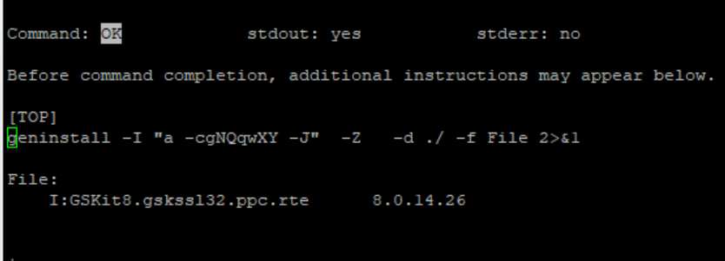

# enter combined keys: “Esc + 0” to exit smitty

lslpp -l | grep gsk

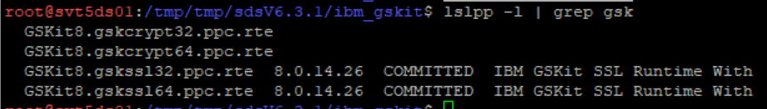

gsk8capicmd_64 -version

